KONFIGURASI MAILSERVER PADA VPS CENTOS7

1. Persiapan
Mail.leon36.web.id
OS: Centos7
IP: 117.53.44.123
domain: mail.leon36.web.id
apache2
php5.6
Wordpress

2.buat ssl dengan cerbot
sudo yum install epel-release -y
sudo yum update
sudo yum install python2-certbot-nginx nginx -y
sudo certbot certonly --standalone -d mail.leon36.web.id
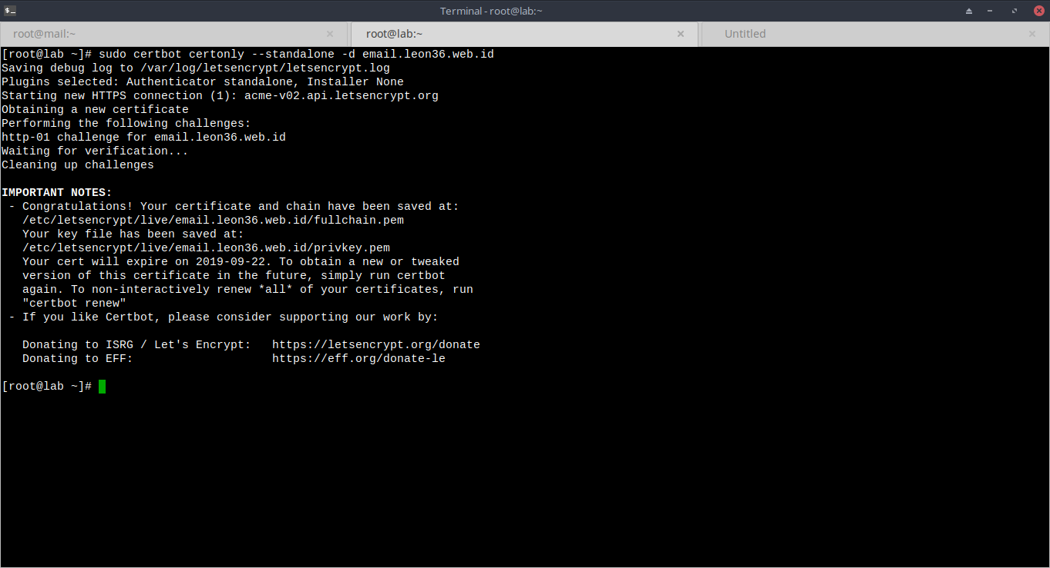
3. Install mariadb, postfix & dovecot
yum install postfix dovecot mariadb-server dovecot-mysql

4. Jalankan dan nyalakan service mariadb
sudo systemctl start mariadb
sudo systemctl enable mariadb
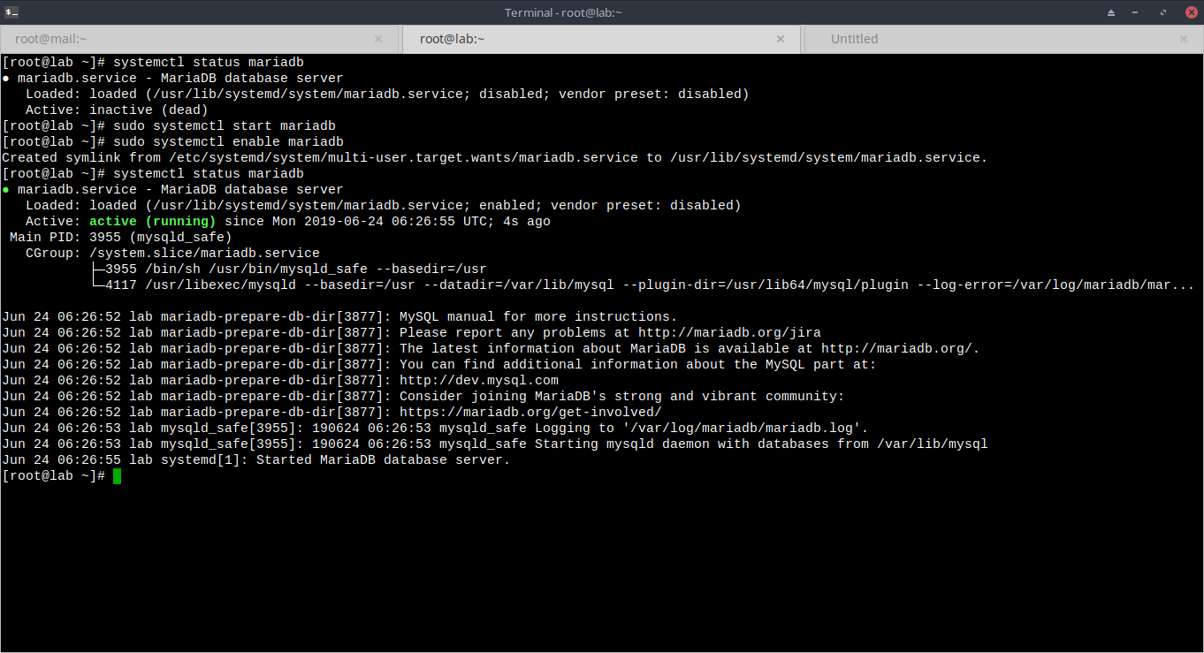
5. buat database untuk mailserver
mysql -u root -e "create database mailserver"
mysql -u root -e "grant all privileges on mailserver.* to 'mailuser'@'localhost' identified by 'scfreWs#$1'"
mysql -u root -e "flush privileges"
mysql -u root -e "show databases"
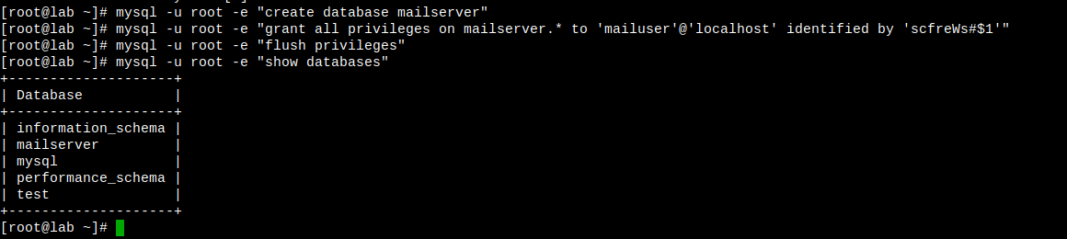
6. Buat tabel untuk virtual_domain, virtual_user dan forwarding
mysql
USE mailserver;
CREATE TABLE `virtual_domains` (
`id` int(11) NOT NULL auto_increment,
`name` varchar(50) NOT NULL,
PRIMARY KEY (`id`)
) ENGINE=InnoDB DEFAULT CHARSET=utf8;

CREATE TABLE `virtual_users` (
`id` int(11) NOT NULL auto_increment,
`domain_id` int(11) NOT NULL,
`password` varchar(106) NOT NULL,
`email` varchar(100) NOT NULL,
PRIMARY KEY (`id`),
UNIQUE KEY `email` (`email`),
FOREIGN KEY (domain_id) REFERENCES virtual_domains(id) ON DELETE CASCADE
) ENGINE=InnoDB DEFAULT CHARSET=utf8;

CREATE TABLE `virtual_aliases` (
`id` int(11) NOT NULL auto_increment,
`domain_id` int(11) NOT NULL,
`source` varchar(100) NOT NULL,
`destination` varchar(100) NOT NULL,
PRIMARY KEY (`id`),
FOREIGN KEY (domain_id) REFERENCES virtual_domains(id) ON DELETE CASCADE
) ENGINE=InnoDB DEFAULT CHARSET=utf8;
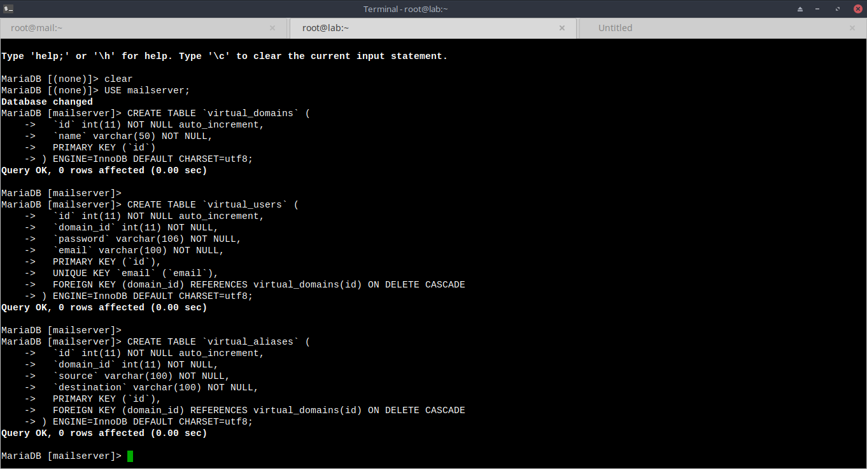
7. tambahkan data pada tabel yang dibuat
mysql
INSERT INTO `mailserver`.`virtual_domains`
(`id` ,`name`)
VALUES
('1', 'mail.leon36.web.id');

INSERT INTO `mailserver`.`virtual_users`
(`id`, `domain_id`, `password` , `email`)
VALUES
('1', '1', ENCRYPT('kmzwa87awaa', CONCAT('$6$', SUBSTRING(SHA(RAND()), -16))), 'test@mail.leon36.web.id'),
('2', '1', ENCRYPT('SecUrEPasswD', CONCAT('$6$', SUBSTRING(SHA(RAND()), -16))), 'infinys@mail.leon36.web.id');

INSERT INTO `mailserver`.`virtual_aliases`
(`id`, `domain_id`, `source`, `destination`)
VALUES
('1', '1', 'alias@mail.leon36.web.id', 'test@mail.leon36.web.id'),
('2', '1', 'siluman@mail.leon36.web.id', 'infinys@mail.leon36.web.id');
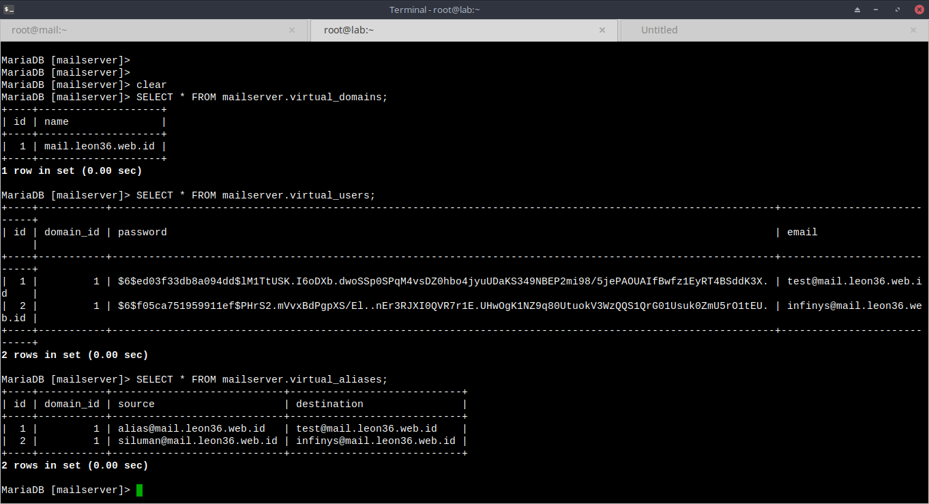
8. Modif konfigurassi postfix
sudo cp /etc/postfix/main.cf /etc/postfix/main.cf.orig
vim /etc/postfix/main.cf
…………………
smtpd_banner = $myhostname ESMTP $mail_name (CentOS)
biff = no

# appending .domain is the MUA's job.
append_dot_mydomain = no

# Uncomment the next line to generate "delayed mail" warnings
#delay_warning_time = 4h

readme_directory = no

# TLS parameters
smtpd_tls_cert_file=/etc/letsencrypt/live/mail.leon36.web.id/fullchain.pem
smtpd_tls_key_file=/etc/letsencrypt/live/mail.leon36.web.id/privkey.pem
smtpd_use_tls=yes
smtp_tls_security_level = may
smtpd_tls_security_level = may

# See /usr/share/doc/postfix/TLS_README.gz in the postfix-doc package for
# information on enabling SSL in the smtp client.
smtpd_relay_restrictions = permit_mynetworks permit_sasl_authenticated defer_unauth_destination
myhostname = localhost
alias_maps = hash:/etc/aliases
alias_database = hash:/etc/aliases
mydomain = mail.leon36.web.id
myorigin = $mydomain
mydestination = localhost, localhost.$mydomain $mydomain
relayhost =
mynetworks = 127.0.0.0/8 [::ffff:127.0.0.0]/104 [::1]/128
mailbox_size_limit = 0
recipient_delimiter = +
inet_interfaces = all
inet_protocols = all

# Handing off local delivery to Dovecot's LMTP, and telling it where to store mail
virtual_transport = lmtp:unix:private/dovecot-lmtp

# Virtual domains, users, and aliases
virtual_mailbox_domains = mysql:/etc/postfix/mysql-virtual-mailbox-domains.cf
virtual_mailbox_maps = mysql:/etc/postfix/mysql-virtual-mailbox-maps.cf
virtual_alias_maps = mysql:/etc/postfix/mysql-virtual-alias-maps.cf,
mysql:/etc/postfix/mysql-virtual-email2email.cf
………………..
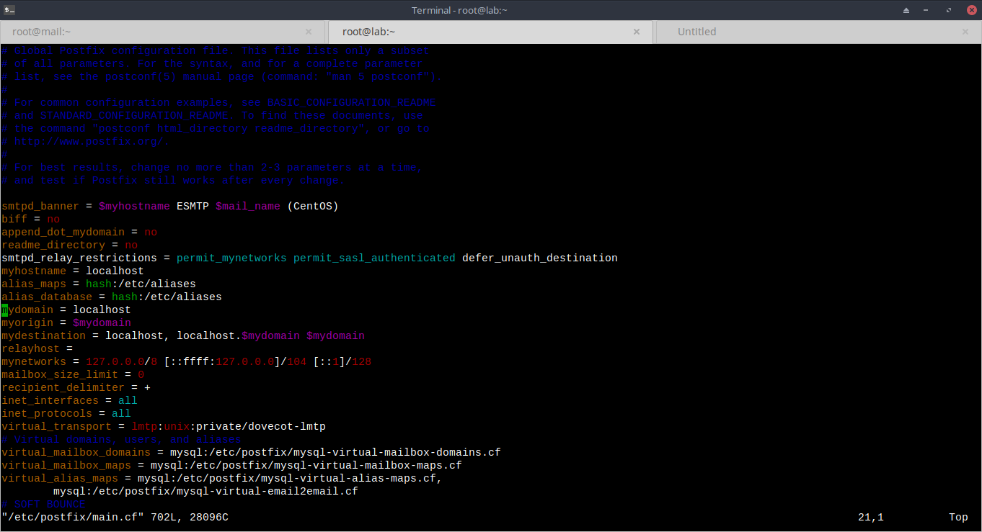
9. Buat koneksi virtual domain
vim /etc/postfix/mysql-virtual-mailbox-domains.cf
.........
user = mailuser
password = scfreWs#$1
hosts = 127.0.0.1
dbname = mailserver
query = SELECT 1 FROM virtual_domains WHERE name='%s'
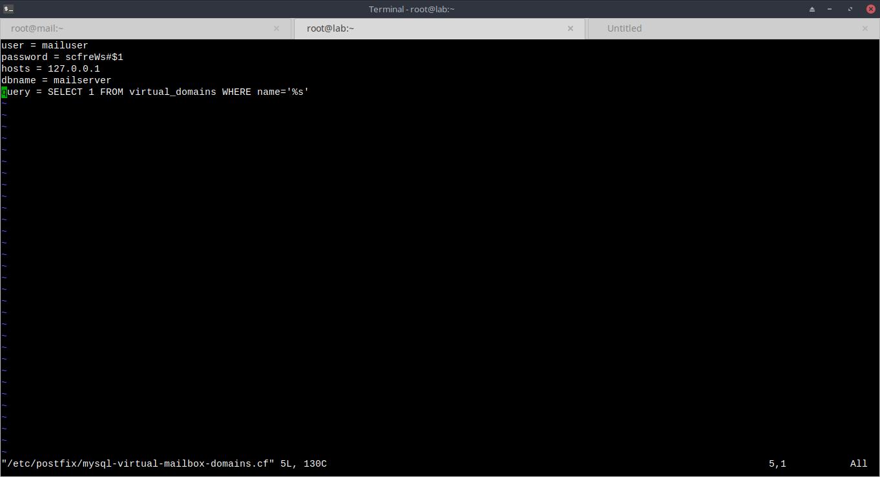
10. Buat koneksi virtual user
vim /etc/postfix/mysql-virtual-mailbox-maps.cf
………….
user = mailuser
password = scfreWs#$1
hosts = 127.0.0.1
dbname = mailserver
query = SELECT 1 FROM virtual_users WHERE email='%s'
……………..
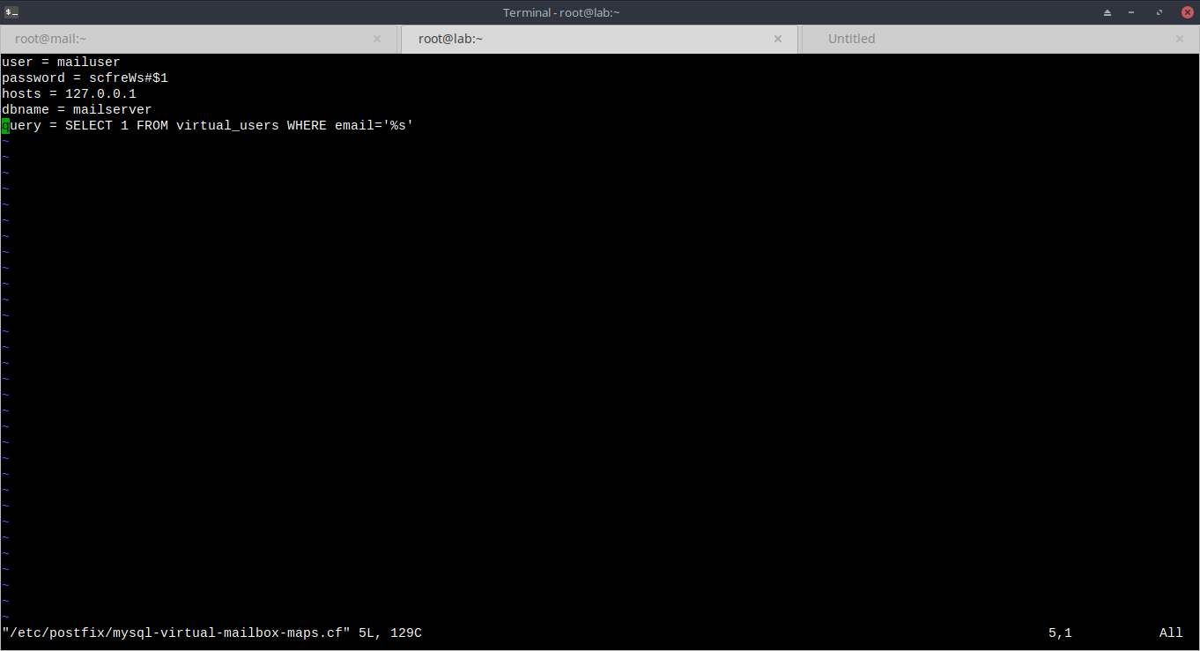
11. buat koneksi forwarding
vim /etc/postfix/mysql-virtual-alias-maps.cf
.........
user = mailuser
password = scfreWs#$1
hosts = 127.0.0.1
dbname = mailserver
query = SELECT destination FROM virtual_aliases WHERE source='%s'
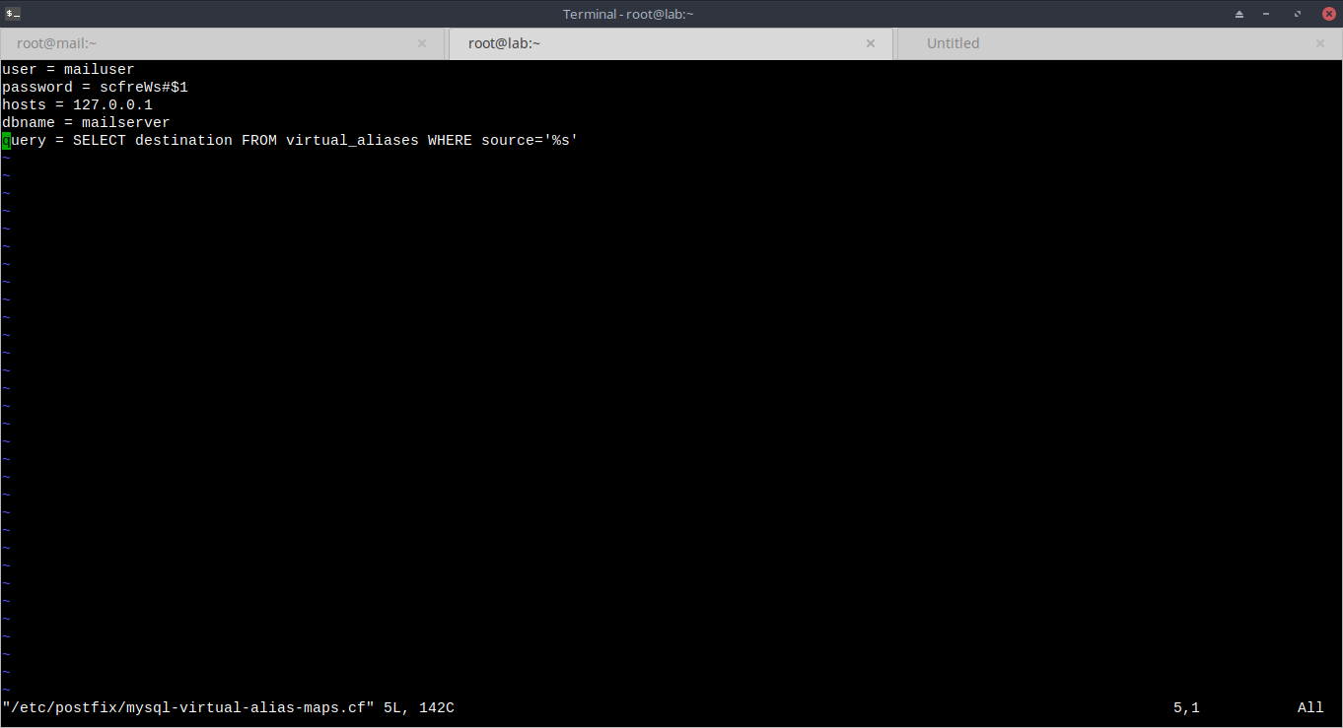
12. buat koneksi email map
vim /etc/postfix/mysql-virtual-email2email.cf
.........
user = mailuser
password = scfreWs#$1
hosts = 127.0.0.1
dbname = mailserver
query = SELECT email FROM virtual_users WHERE email='%s'
13. Restart konfigurasi postfix
postfix reload

14. Test koneksi database pastikan outputnya “1”
sudo postmap -q mail.leon36.web.id mysql:/etc/postfix/mysql-virtual-mailbox-domains.cf
sudo postmap -q test@mail.leon36.web.id mysql:/etc/postfix/mysql-virtual-mailbox-maps.cf
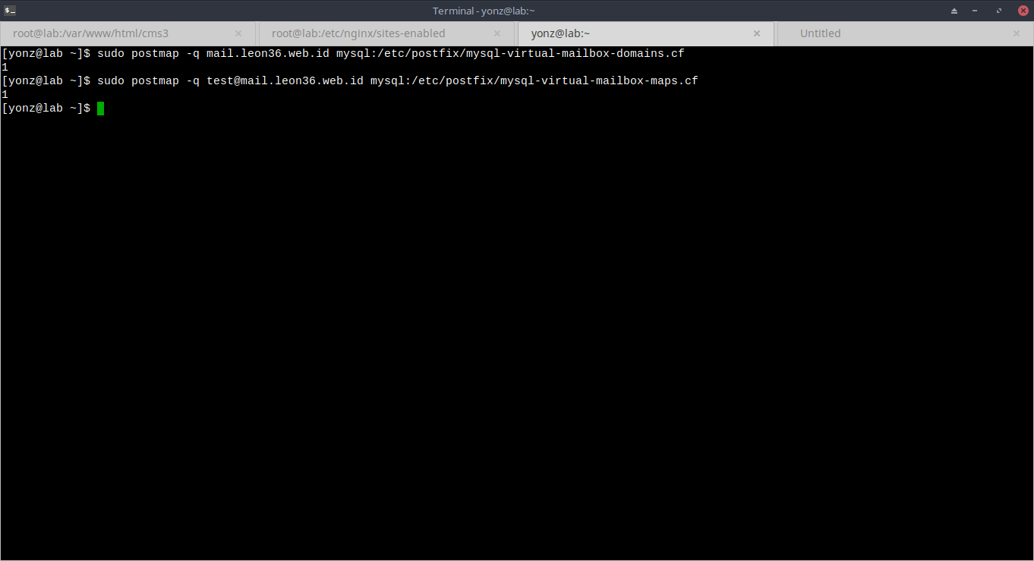
15. konfigurasi master postfix
sudo cp /etc/postfix/master.cf /etc/postfix/master.cf.orig
vim /etc/postfix/master.cf
………………….
smtp inet n - n - - smtpd

#smtp inet n - n - 1 postscreen
#smtpd pass - - n - - smtpd
#dnsblog unix - - n - 0 dnsblog
#tlsproxy unix - - n - 0 tlsproxy
submission inet n - n - - smtpd
-o syslog_name=postfix/submission
-o smtpd_tls_security_level=encrypt
-o smtpd_sasl_auth_enable=yes
-o smtpd_reject_unlisted_recipient=no
-o smtpd_client_restrictions=$mua_client_restrictions
-o smtpd_helo_restrictions=$mua_helo_restrictions
-o smtpd_sender_restrictions=$mua_sender_restrictions
-o smtpd_recipient_restrictions=permit_sasl_authenticated,reject
-o milter_macro_daemon_name=ORIGINATING
……………
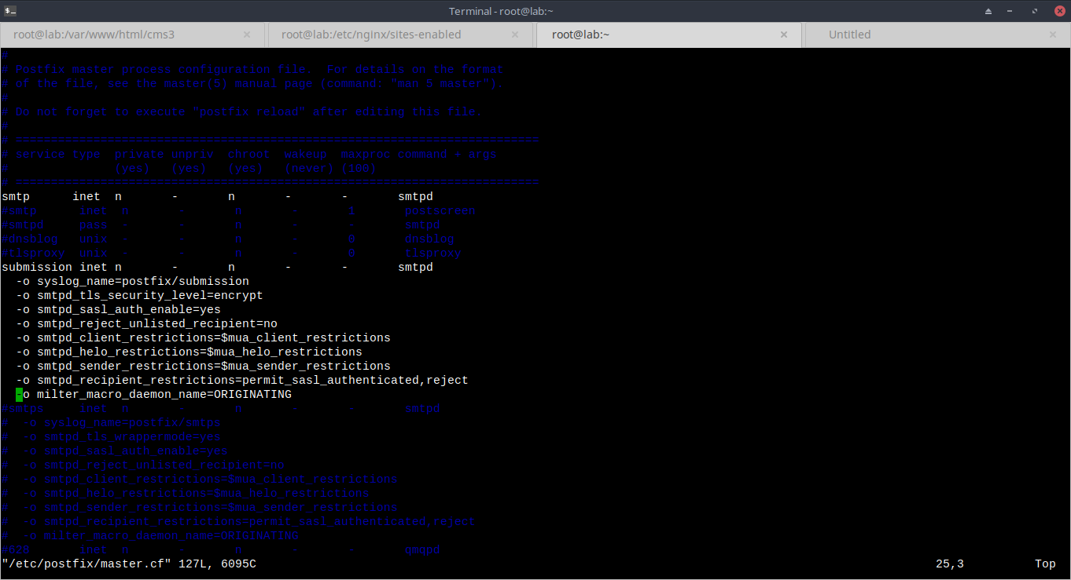
16. Ganti permision pada file koneksi yang sudah dibuat menjadi 640
chmod 640 /etc/postfix/mysql-*
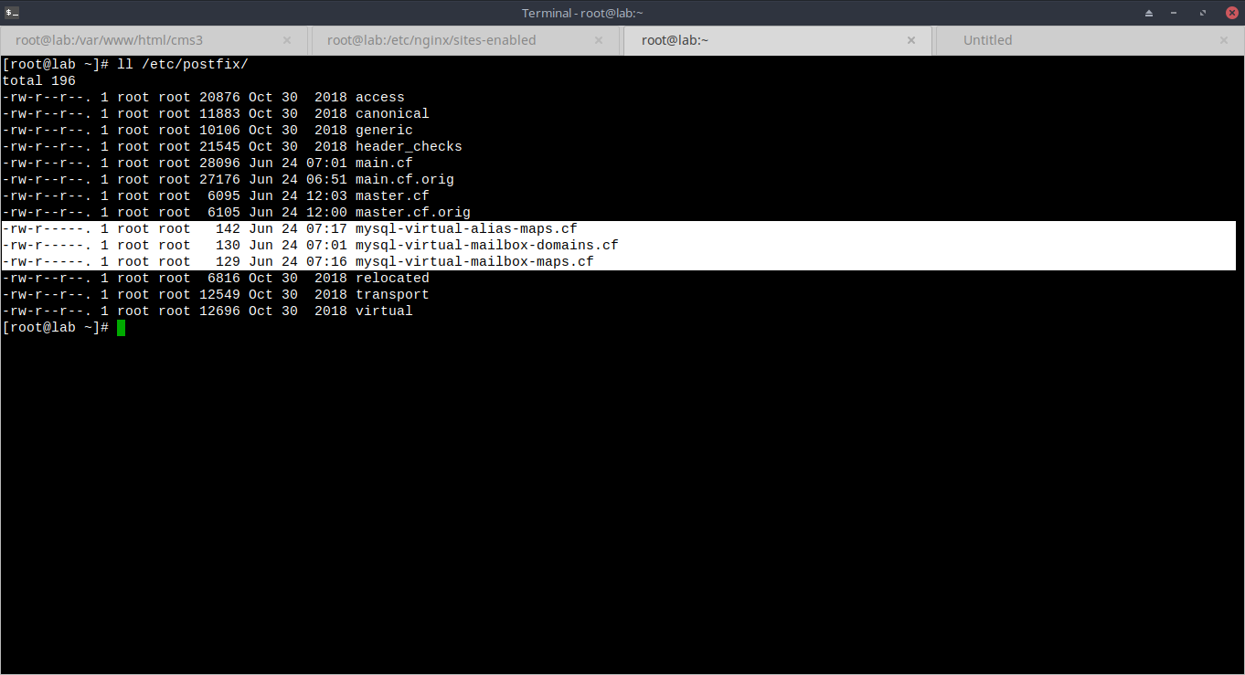
17. Restart service postfix
postfix reload

18. backup konfigurasi file dovecot
sudo cp /etc/dovecot/dovecot.conf /etc/dovecot/dovecot.conf.orig
sudo cp /etc/dovecot/conf.d/10-mail.conf /etc/dovecot/conf.d/10-mail.conf.orig
sudo cp /etc/dovecot/conf.d/10-auth.conf /etc/dovecot/conf.d/10-auth.conf.orig
sudo cp /etc/dovecot/conf.d/auth-sql.conf.ext /etc/dovecot/conf.d/auth-sql.conf.ext.orig
sudo cp /etc/dovecot/conf.d/10-master.conf /etc/dovecot/conf.d/10-master.conf.orig
sudo cp /etc/dovecot/conf.d/10-ssl.conf /etc/dovecot/conf.d/10-ssl.conf.orig

19. konfigurasi file dovecot.conf
vim /etc/dovecot/dovecot.conf
……………
## Dovecot configuration file
..........
# Protocols we want to be serving.
protocols = imap pop3 lmtp
listen = *, ::
......…
………………….

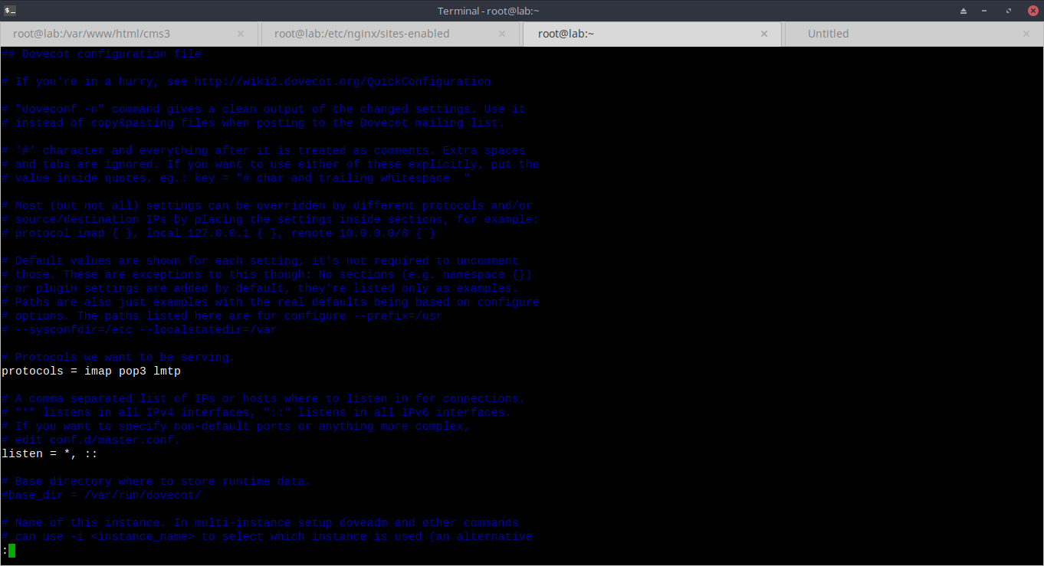
20. konfigurasi file mail
vim /etc/dovecot/10-mail.conf
…………
mail_location = maildir:/home/vmail/vhosts/%u/%d
...
mail_privileged_group = mail
..
mail_uid = 2010
mail_gid = 89
........……….

21. Buat user baru untuk mailbox
sudo groupadd -g 5000 vmail
sudo useradd -g vmail -u 5000 vmail -d /home/vmail/
chmod -R 655 /home/vmail
chown -R vmail:root /home/vmail/

22. buat file koneksi untuk verifikasi virtual user
vim /etc/dovecot/dovecot-sql.conf.ext
………..
driver = mysql
connect = host=127.0.0.1 dbname=mailserver user=mailuser password= scfreWs#$1
default_pass_scheme = SHA512-CRYPT
password_query = SELECT email as user, password FROM virtual_users WHERE email='%u';
user_query = SELECT email as user, password FROM virtual_users WHERE email='%u';
………………
chmod 640 /etc/dovecot/dovecot-sql.conf.ext
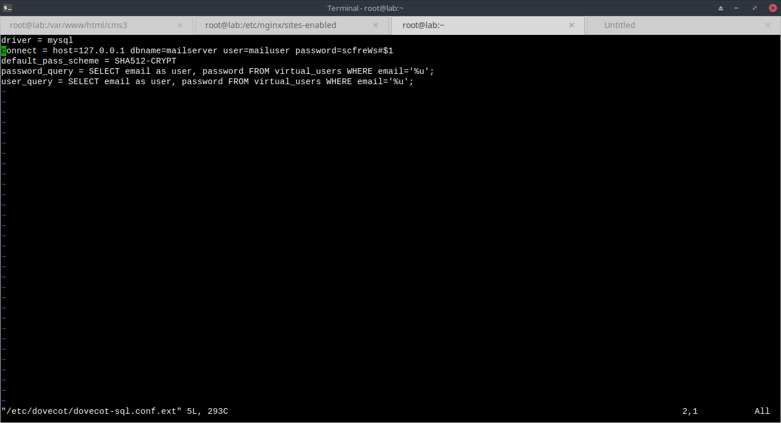
23. ganti kepemilikan dir dovecot
sudo chown -R vmail:dovecot /etc/dovecot

24. edit konfigurasi pada master dovecot
vim /etc/dovecot/conf.d/10-master.conf
…………..
service imap-login {
inet_listener imap {
port = 143
}
inet_listener imaps {
port = 993
ssl = yes
}
.......
service pop3-login {
inet_listener pop3 {
port = 110
}
inet_listener pop3s {
port = 995
ssl = yes
}
}
.........
service lmtp {
unix_listener /var/spool/postfix/private/dovecot-lmtp {
mode = 0600
user = postfix
group = postfix
}
.........
service auth {
unix_listener /var/spool/postfix/private/auth {
mode = 0666
user = postfix
group = postfix
}
unix_listener auth-userdb {
mode = 0600
user = vmail
}
user = dovecot
}
.........
service auth-worker {
user = vmail
}
……….
25. konfigurasi SSL
vim /etc/dovecot/conf.d/10-ssl.conf
.............
ssl = required
ssl_cert = </etc/letsencrypt/live/mail.leon36.web.id/fullchain.pem
ssl_key = </etc/letsencrypt/live/mail.leon36.web.id/privkey.pem
.....…

26. restart service dovecot
systemctl restart dovecot

26. Test configuration menggunakan telnet
#from outside network (local device)
telnet mail.leon36.web.id 25
ehlo mail.leon36.web.id
mail from:test@mail.leon36.web.id
rcpt to:infinys@mail.leon36.web.id
data
subjek: hello from test
whatsupp!

.

27. install paket php
yum install http://rpms.remirepo.net/enterprise/remi-release-7.rpm -y
yum-config-manager --enable remi-php71
yum -y install php php-common php-opcache php-mcrypt php-cli php-gd php-curl php-mysqlnd php-dom php-curl php-zip php-mbstring php-xml php-xmlreader php-simplexml php-bcmath php-soap php-amqplib php-fpm wget unzip

28. Install nginx
yum -y install nginx
systemctl start nginx
systemctl enable nginx
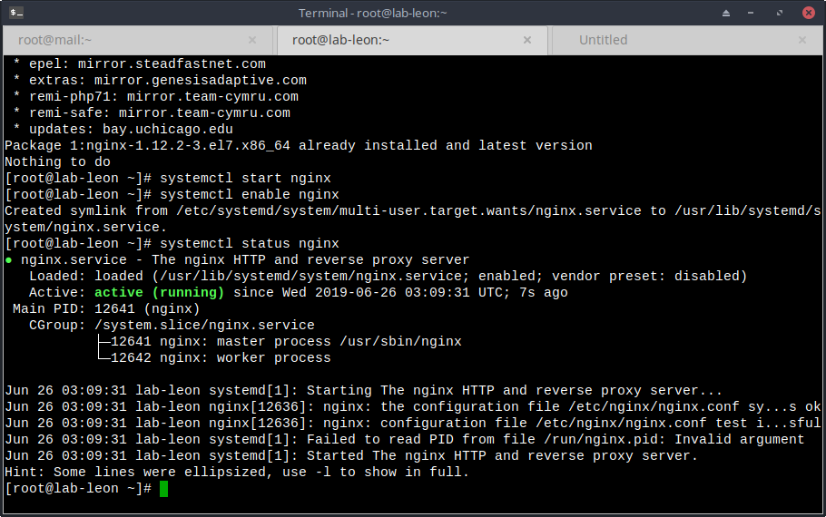
29. Buat dir sites-available dan site-enabled
mkdir /etc/nginx/sites-available
mkdir /etc/nginx/sites-enabled

30. Tambahkan include pada config nginx
vim /etc/nginx/nginx.conf
.....
#in section http
http{
......
include /etc/nginx/sites-enabled/*;
}
..…

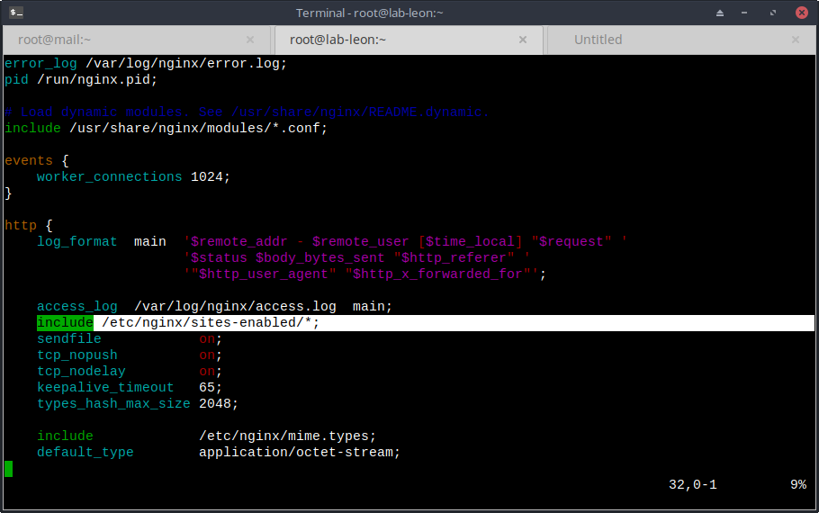
31. Jalankan service php-fpm
service php-fpm start
service php-fpm enable
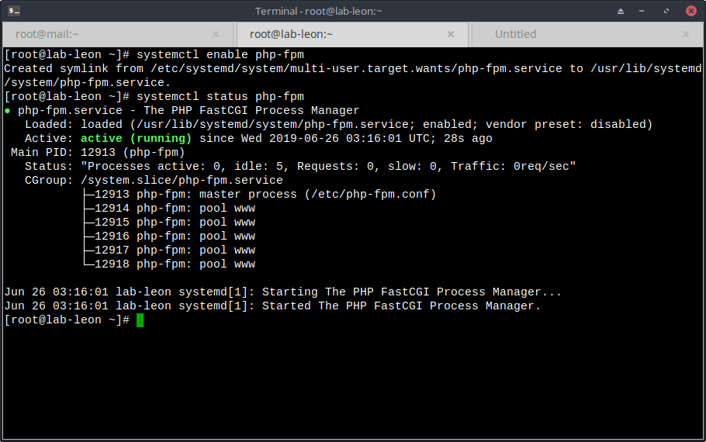
32. buat database untuk manajemen user roundcube
mysql
create database roundcubemail;
grant all privileges on roundcubemail.* to 'roundcube'@'localhost' identified by 'tHiZP4ssWd';
flush privileges;
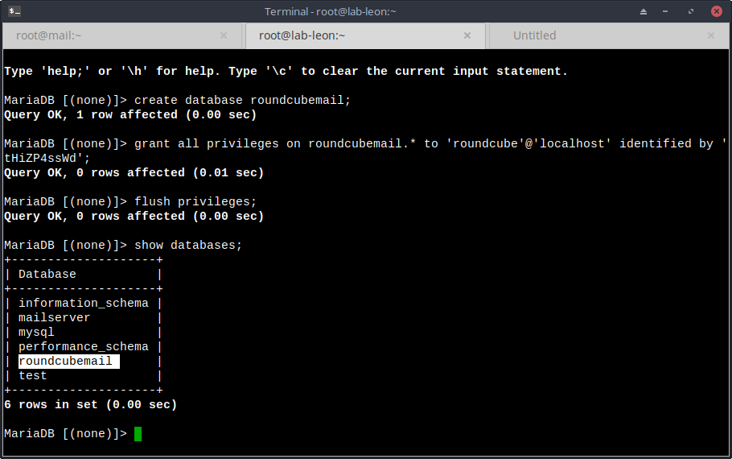
33. Download roundcube
wget https://github.com/roundcube/roundcubemail/releases/download/ 1.3.8/roundcubemail-1.3.8.tar.gz
tar xfvz roundcubemail-1.3.8.tar.gz -C /var/www/html/roundcubemail

34. ubah permisision pada php-fpm
vim /etc/php-fpm.d/www.conf
..........
listen.owner = nginx
listen.group = nginx
listen.mode = 0660

user = nginx
group = nginx

listen = /var/run/php-fpm/php-fpm.sock
.......…
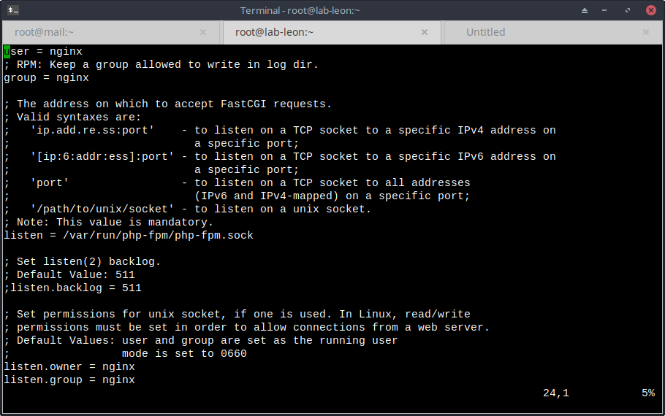
35. restart service php-fpm
service php-fpm restart

36. ganti kepemilikan session php
chown :nginx /var/lib/php/session/

37. buat virtualhost untuk roundcube
vim /etc/nginx/sites-available/email.leon36.web.id.conf
...........................
server {
server_name mail.leon36.web.id;

root /var/www/html/roundcubemail;
index index.php index.html;

#i# Logging
access_log /var/log/nginx/mail.leon36.web.id_access_log;
error_log /var/log/nginx/mail.leon36.web.id_error_log;

location / {
try_files $uri $uri/ /index.php?q=$uri&$args;
}

location ~ ^/(README.md|INSTALL|LICENSE|CHANGELOG|UPGRADING)$ {
deny all;
}

location ~ ^/(config|temp|logs)/ {
deny all;
}

location ~ /\. {
deny all;
access_log off;
log_not_found off;
}

location ~ \.php$ {
include /etc/nginx/fastcgi_params;
fastcgi_pass unix:/var/run/php-fpm/php-fpm.sock;
fastcgi_index index.php;
fastcgi_param SCRIPT_FILENAME $document_root$fastcgi_script_name;
}

}
................
nginx -s reload
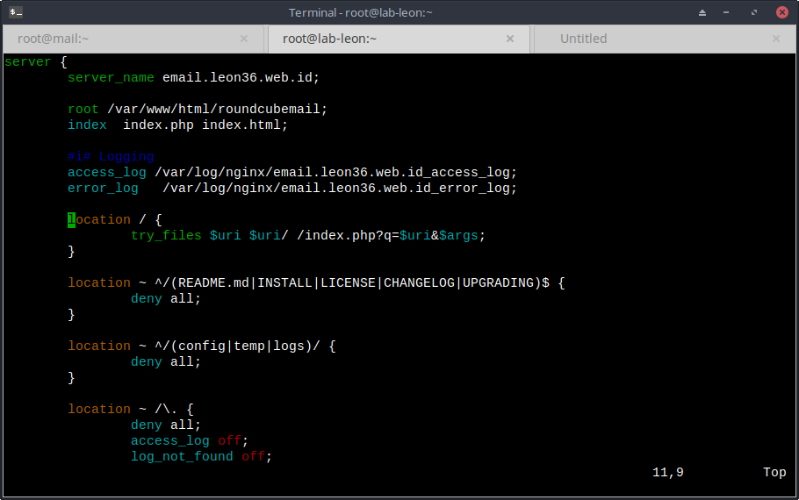
38. Install SSL menggunakan certbot
sudo certbot --nginx --agree-tos --redirect --hsts --email leon@isi.co.id -d email.leon36.web.id
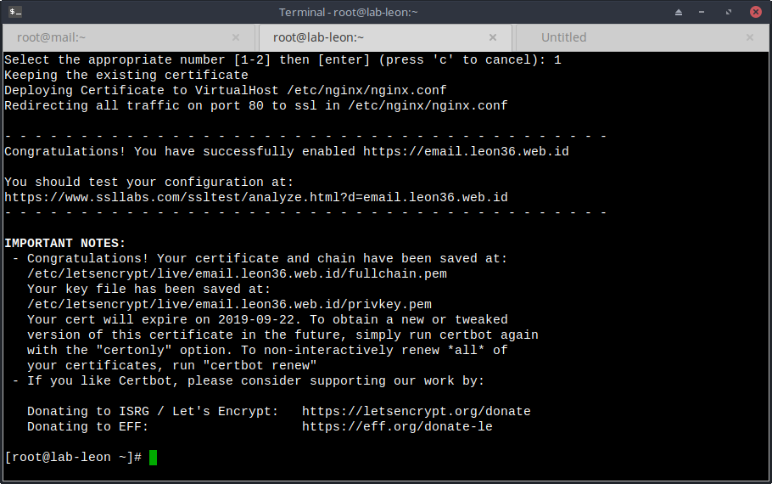
39. masuk ke direktori roundcube
cd /var/www/html/roundcubemail
cp composer.json-dist composer.json
#Pindahkan field sugest to required
composer install
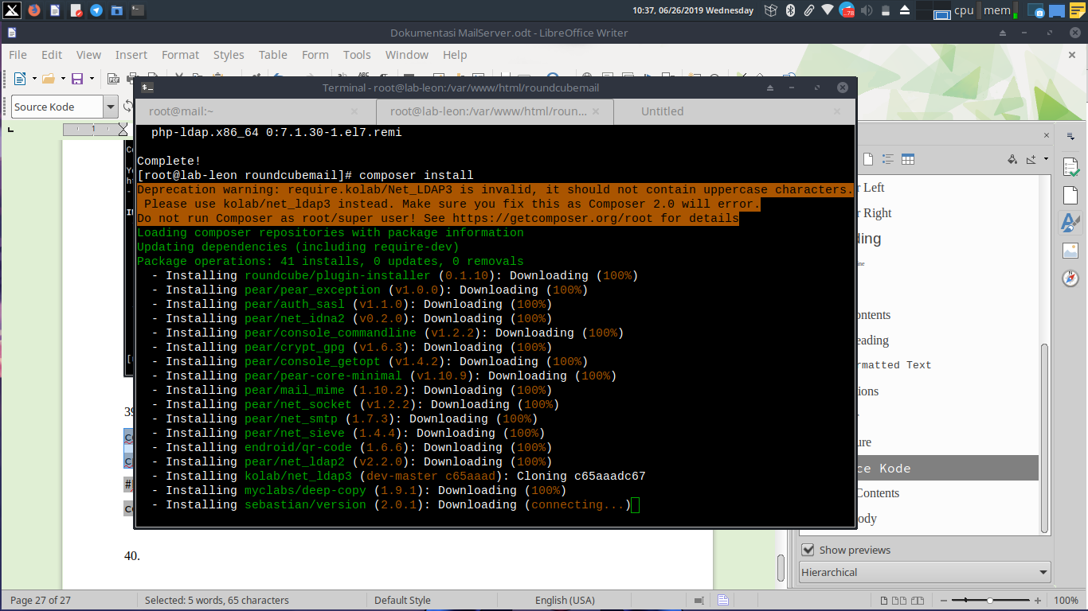
40. Modif file install-jsdeph.sh
#tambahkan flag -L pada baris Berikut
exec(sprintf('%s -s %s -o %s', $CURL, escapeshellarg($package['url']), $cache_file), $out, $retval);
#TO
exec(sprintf('%s -s %s -o %s -L', $CURL, escapeshellarg($package['url']), $cache_file), $out, $retval);

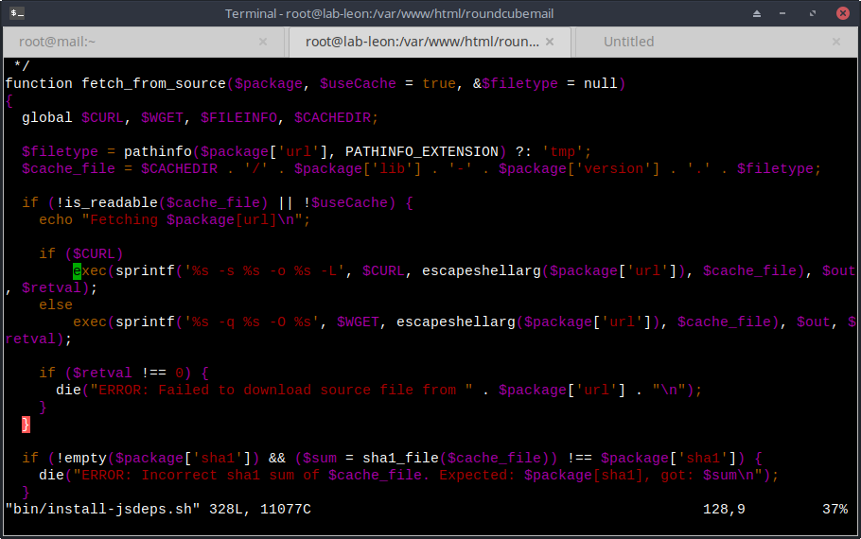
41. install dependensi roundcube
./bin/install-jsdeps.sh
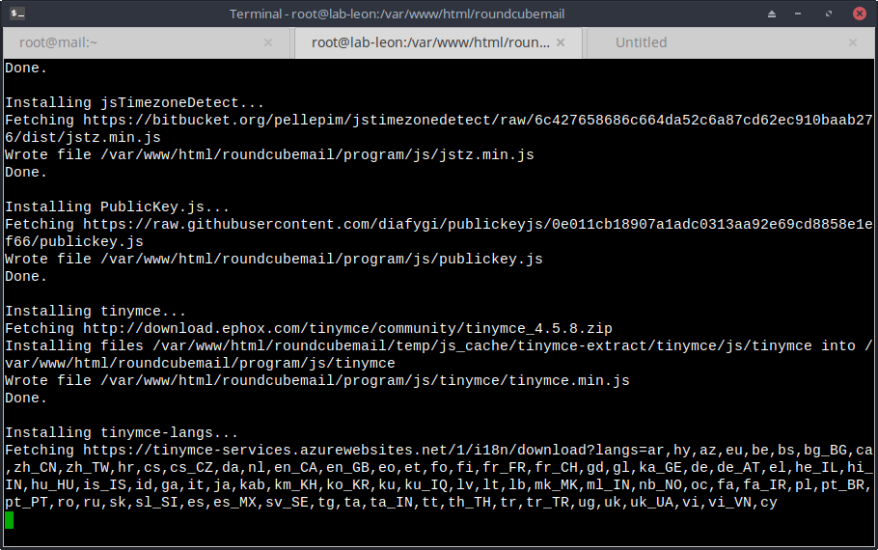
42. Install Roundcube
